Project Wise Outlook Mail Generator – Design Document And Use Case
Use Case
Daily component check-ins need to be communicated to Authorised Person. This application automates the process by reading Excel data, grouping it by project, and generating structured Outlook emails for each project team.
1. Introduction
The Project Wise Outlook Mail Generator is a Windows desktop application developed using C# (.NET) that automates the process of reading Excel data and generating structured email drafts in Microsoft Outlook.
The application extracts project-specific component data, groups it intelligently, and prepares formatted emails with tables for easy communication.
2. Objective
The main objective of this application is to:
- Automate manual email reporting
- Reduce human errors in data sharing
- Improve efficiency in project communication
- Provide structured and professional email reports
3. Key Features
- Read data from Excel (.xlsx)
- Supports multiple sheets (P1Proj, P2Proj)
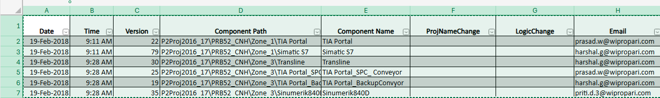
These columns are required in Excel for both P1Proj and P2Proj sheets
- Extract only required columns:
  - Date
  - Time
  - Version
  - Component Path
  - Component Name
- Filter data:
  - Only today’s records
  - Custom date range (From–To)
- Identify project from Component Path
- Group data project-wise
- Combine multiple email IDs into a single mail
- Generate HTML table in email body
- Auto-append Outlook signature (Sign1)
- Create Outlook draft emails for review
4. System Architecture
Components:
- UI Layer (WinForms)
  - File selection
  - Date filter controls
  - Data preview grid
  - Action buttons
- Excel Reader
  - Reads data from Excel
  - Supports large file handling
  - Filters data during reading
- Business Logic Layer
  - Extract project name
  - Group data project-wise
  - Merge email recipients
- HTML Builder
  - Generates formatted email body
  - Creates table structure
- Outlook Integration
  - Creates email drafts
  - Adds CC recipients
  - Appends signature
5. Workflow
- User selects Excel file
- User chooses filter (Today / Date Range)
- Application reads Excel data
- Filters data based on date
- Extracts project name from Component Path
- Groups data project-wise
- Prepares HTML table
- Creates Outlook draft emails
- User reviews and sends emails
6. Data Flow
Excel File → Excel Reader → Filter → Grouping → HTML Builder → Outlook Draft
7. Technologies Used
- C# (.NET Framework)
- WinForms
- ExcelDataReader / ClosedXML
- Microsoft Outlook Interop
- HTML (for email formatting)

8. Key Methods with Code and Output
1. Program.cs
Purpose:
Application entry point.
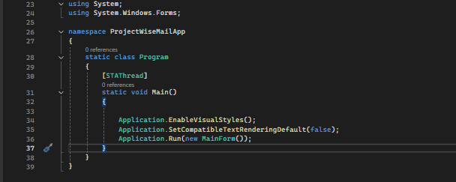
Why Used:
- Starts the application
- Loads the main form
- Controls application initialization
- Main() method
- Launch MainForm
2. MainForm.cs
Purpose:
Main UI screen of the application.
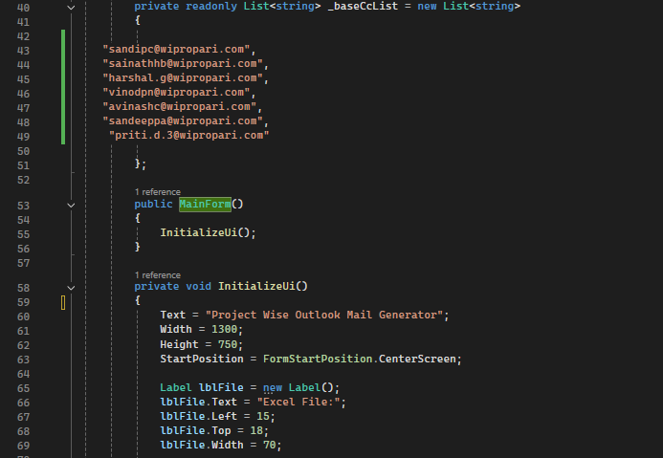
Why Used:
- User selects Excel file
- User selects filters
- User clicks Load Excel / Create Drafts
- UI controls
- Button click events
- Calling services

3. Form1.cs
Purpose:
Additional UI form (if used for testing / legacy UI)
Why Used:
- Secondary UI screen
- Testing UI (Optional)
4. Form1.Designer.cs
Purpose:
Auto-generated UI design file.
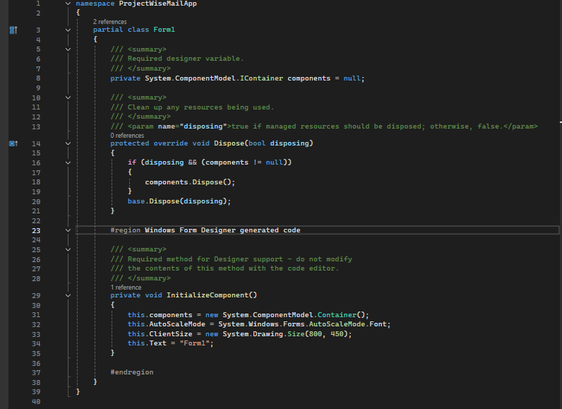
Why Used:
- Contains UI layout code
- Created automatically by Visual Studio

5. ExcelReader.cs
Purpose:
Reads Excel file data.
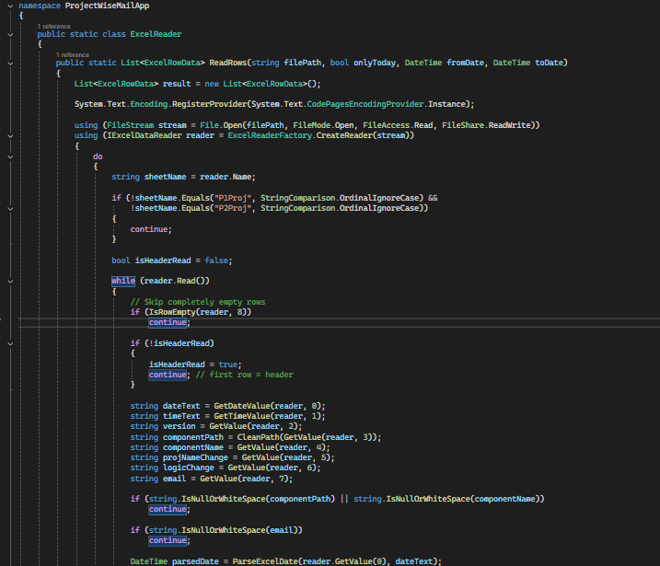
Why Used:
- Read P1Proj & P2Proj sheets
- Loop through rows
- Extract column values
- Read Excel
- Parse rows
- Return structured data
6. ExcelRowData.cs
Purpose:
Model class to store Excel row data.
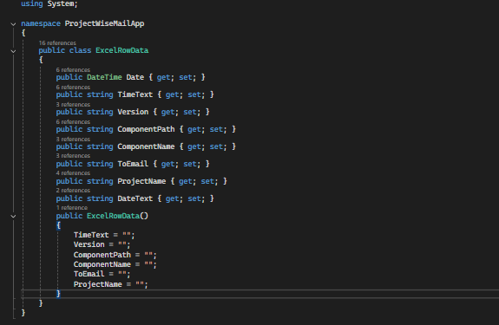
Why Used:
- Store Date
- Store Version
- Store Component Name
- Store Email IDs
- Data container class
- Date
- Version
- ComponentPath
- ComponentName
- ProjectName
- Email
7. HtmlMailBuilder.cs
Purpose:
Generate HTML email body.
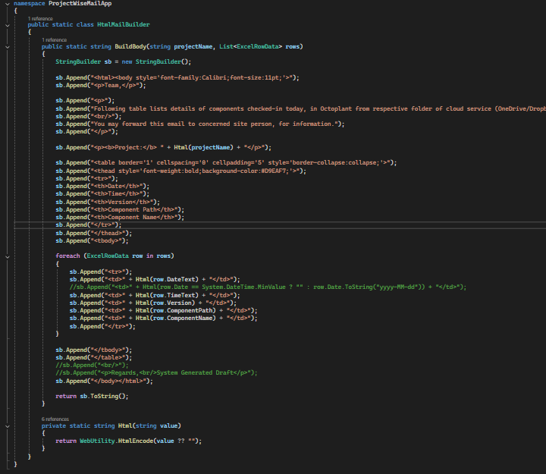
Why Used:
- Build HTML table
- Format mail content
- Apply styling
- Generate mail body

8. MailGroupingService.cs
Purpose:
Group data by Project.
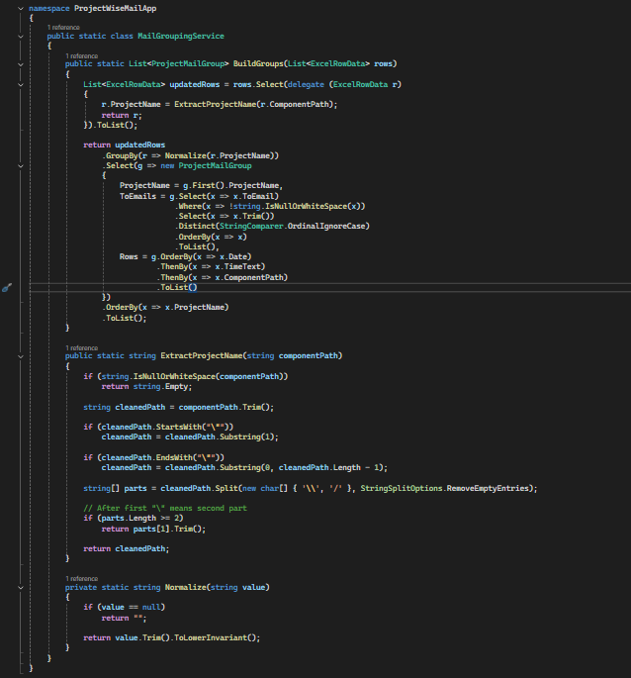
Why Used:
- Group rows by project name
- Merge email IDs
- Prepare mail data
- Group rows
- Merge data
9. ProjectMailGroup.cs
Purpose:
Model for grouped mail data.
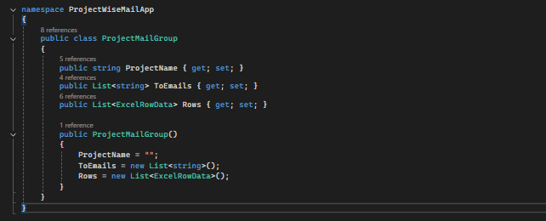
Why Used:
- Store grouped project data
- Store email list
- Store table rows
- Data container
10. OutlookHelper.cs
Purpose:
Create Outlook draft emails.
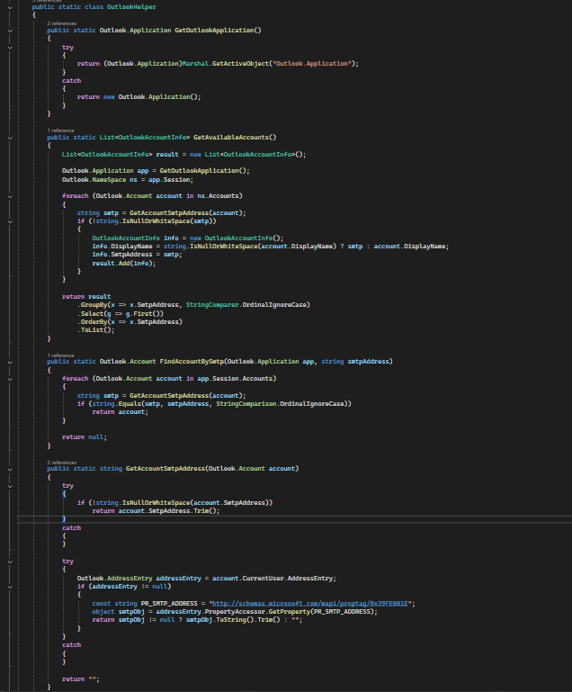
Why Used:
- Create mail drafts
- Add recipients
- Add subject
- Add body
- Open Outlook
- Create draft
- Insert HTML
11. OutlookAccountInfo.cs
Purpose:
Stores Outlook account details.
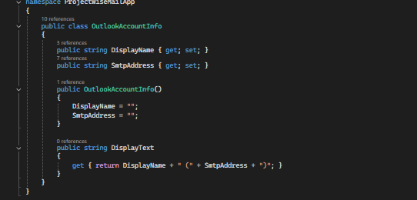
9. Advantages
- Saves manual effort
- Handles large Excel files efficiently
- Reduces email errors
- Improves communication clarity
- Easy to use (desktop-based)
10. Conclusion
This application simplifies project-wise reporting by automating Excel data processing and email generation. It enhances productivity and ensures accurate, structured communication across teams.
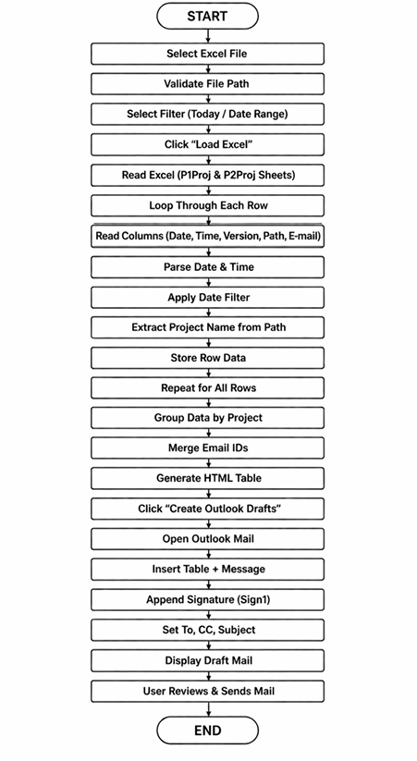
Flowchart :

